|  |
| --- |
| THE COFFEE STORIES MANEGMENT SYSTEM |
|  |



**Acknowledgement**

I have taken efforts in this project. However, it would not have been possible without the kind support and help of many individuals and organizations. I would like to extend my sincere thanks to all of them.

I am highly indebted to **Mr. Anjana Kahawevitharana** for his guidance and constant supervision as well as for providing necessary information regarding the project & also for their support in completing the project.

I would like to express our gratitude towards my teachers for their kind co-operation and encouragement which help me in completion of this project.

My thanks and appreciations also go to our colleague in developing the project and people who have willingly helped me out with their abilities.

Contents

SDLC 1

Waterfall Development 1

Introduction to Coffee Shop Management System 2

Existing System and Structure of Coffee Shop 2

Objectives of Project 3

Main Functions in the system 3

ITEMS 3

EMPLOYEES 3

SUPPLIERS 3

Use Case Diagram 4

Class Diagram 5

ER Diagram 6

Login Interfaces with Codes 8

Welcome Page 8

Login Page 10

Main menu 13

Items 16

Employees 19

Suppliers 22

Update Item 25

Add Item 28

View Item 31

Delete Item 34

Update Employee 36

Add Employee 39

View Employee 42

Delete Employee 45

Update Supplier 49

Insert Supplier 52

View Supplier 55

Delete Supplier 58

Customer Page 62

Espresso 65

Beverages 67

Sandwiches 69

Sweets 71

Test Plan 73

Future Scope 74

Conclusion 75

References 76

# SDLC

The software development methodology (also known as SDM) framework didn't emerge until the 1960s. According to Elliott (2004) the [Systems Development Life Cycle](https://en.wikipedia.org/wiki/Systems_development_life_cycle) (SDLC) can be considered to be the oldest formalized methodology framework for building [Information Systems](https://en.wikipedia.org/wiki/Information_system). The main idea of the SDLC has been "to pursue the development of information systems in a very deliberate, structured and methodical way, requiring each stage of the life cycle from inception of the idea to delivery of the final system to be carried out rigidly and sequentially" within the context of the framework being applied. The main target of this methodology framework in the 1960s was "to develop large scale functional [Business systems](https://en.wikipedia.org/wiki/Business_system) in an age of large scale business conglomerates. Information systems activities revolved around heavy [Data processing](https://en.wikipedia.org/wiki/Data_processing) and [Number crunching](https://en.wikipedia.org/wiki/Number_crunching) routines".

## Waterfall Development

[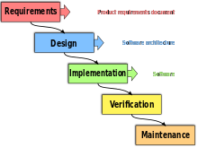](https://en.wikipedia.org/wiki/File:Waterfall_model.svg)

The activities of the software development process represented in the [waterfall model](https://en.wikipedia.org/wiki/Waterfall_model). There are several other models to represent this process.

The waterfall model is a sequential development approach, in which development is seen as flowing steadily downwards (like a waterfall) through several phases, typically.

1. Requirements
2. Design
3. Implementation
4. Verification
5. Maintenance

**What is.NET Framework**

The .Net framework is a software development platform developed by Microsoft. The framework was meant to create applications, which would run on the Windows Platform. The first version of the .Net framework was released in the year 2002.

The version was called .Net framework 1.0. The .Net framework has come a long way since then, and the current version is 4.7.1.

The .Net framework can be used to create both - **Form-based**and**Web-based** applications.[Web services](https://www.guru99.com/web-services-tutorial.html)can also be developed using the .Net framework.

The framework also supports various programming languages such as Visual Basic and C#. So developers can choose and select the language to develop the required application. In this chapter, you will learn some basics of the .Net framework.0

# Introduction to Coffee Shop Management System

Our coffee makes our customers feel happy and warm like Perfect rays of the coffee stories. With the best sorted coffee beans from across the country, we strive to provide the most Refreshing coffee. To offer exquisite tastes, from classic-retro flavors’ to the most trending ones to all coffee lovers under one roof is our aim.

With a broad customer base, aspire to become the favorite Coffee brand of the people. At our cafe, we want to make our whether it is to kick-start the day, relax after a long day.

customers feel like it’s a Sunday morning even on a Monday.

The coffee stories is the place to be. The tagline which we impression about the coffee shop.

have chosen is “expresso yourself”. It creates a first

# **Existing System and** **Structure of Coffee Shop**

As a Usual coffee shop this shop consist of various kind of coffee items that customer expect. So when customer came to the shop he or she can directly order the relevant coffee item by looking at the Menu. Furthermore if they are willing to have some kind of foods they can ask and take their meals as they wish. After they make an order they order will delivered within few minutes with the invoice. All the functions are handled by manually and there is no any kind of computer based system.

**Main Problems of Existing System**

There is no method,

To identify product names and types. All the details must memorize.

To find out Employee details and supplier details.

To Generate Bills automatically

# Objectives of Project

* To Add update view Employee supplier Details in the shop
* To view the products in the coffee shop to the customer

# Main Functions in the system

## ITEMS

* Update Items
* Insert Items
* View Items
* Delete Items

## EMPLOYEES

* Update Employees
* Insert Employees
* View Employees
* Delete Employees

## SUPPLIERS

* Update Suppliers
* Insert Suppliers
* View Suppliers
* Delete Suppliers
* To View Products in the Coffee Shop for Customers

# Use Case Diagram

Cashier

Admin/Manager

# Class Diagram

Supplier

Supplier_ID: varchar ( )

Name: varchar ( )

Age: int ( )

NIC: varchar ( )

Address: varchar ( )

Contact: int ( )

Email: varchar ( )

Add Supplier ( )

Update Supplier ( )

View Supplier ( )

Delete Supplier ( )

Employee

Emloyee_ID: int ( )

Name: varchar ( )

Age: int ( )

NIC: varchar ( )

Gender: varchar ( )

Address: varchar ( )

Contact: int ( )

Email: varchar ( )

Joining_Date: varchar ( )

Add Employee ( )

Update Employee ( )

View Employee ( )

Delete Employee ( )

Item

Category: varchar ( )

Item_ID: varchar ( )

Name: varchar ( )

Quantity: varchar ( )

Price: varchar ( )

Add Item ( )

Update Item ( )

View Item ( )

Delete Item ( )

# ER Diagram

Employee

Items

Suppliers

# Login Interfaces with Codes

# Welcome Page

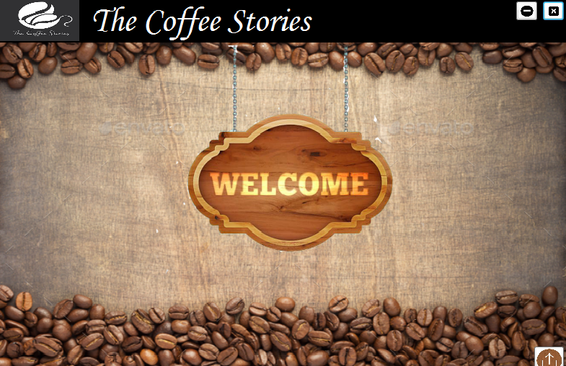

Using System;

Using System.Collections.Generic;

Using System.ComponentModel;

Using System.Data;

Using System.Drawing;

Using System.Linq;

Using System.Text;

using System.Threading.Tasks;

using System.Windows.Forms;

namespace WindowsFormsApplication3

{

public partial class Welcome : Form

{

public Welcome()

{

InitializeComponent();

}

private void button1_Click(object sender, EventArgs e)

{

}

private void button3_Click(object sender, EventArgs e)

{

Application.Exit();

}

private void button2_Click(object sender, EventArgs e)

{

this.WindowState = FormWindowState.Minimized;

}

private void button1_Click_1(object sender, EventArgs e)

{

Login obj = new Login();

obj.Show();

this.Hide();

}

}

}

# Login Page

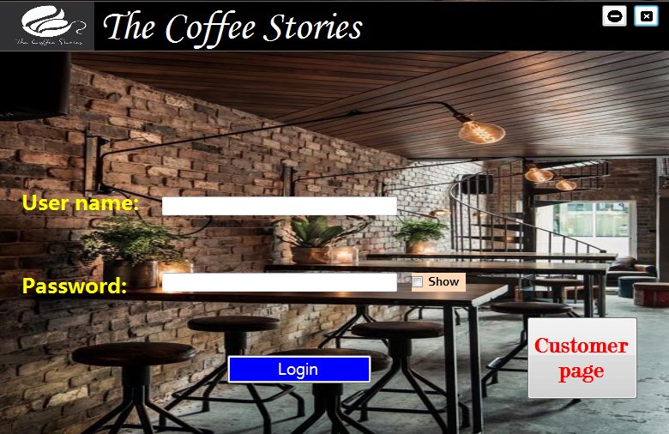

using System;

using System.Collections.Generic;

using System.ComponentModel;

using System.Data;

using System.Drawing;

using System.Linq;

using System.Text;

using System.Threading.Tasks;

using System.Windows.Forms;

namespace WindowsFormsApplication3

{

public partial class Login : Form

{

public Login()

{

InitializeComponent();

textBoxPassword.PasswordChar = '*';

textBoxPassword.MaxLength = '8';

}

private void buttonLogin_Click(object sender, EventArgs e)

{

if (textBoxUsername.Text == "admin" && textBoxPassword.Text == "admin123")

{

MessageBox.Show("Login Success!");

main_menu obj = new main_menu();

obj.Show();

this.Hide();

}

else

{

MessageBox.Show("Login Unsuccess!");

}

}

private void checkBoxShow_CheckedChanged(object sender, EventArgs e)

{

textBoxPassword.PasswordChar = (checkBoxShow.Checked ? char.MinValue : '*');

}

private void buttonCustomer_Click(object sender, EventArgs e)

{

ItemsCustomer obj = new ItemsCustomer();

obj.Show();

this.Hide();

}

private void button1_Click(object sender, EventArgs e)

{

Application.Exit();

}

private void button2_Click(object sender, EventArgs e)

{

this.WindowState = FormWindowState.Minimized;

}

}

}

# Main menu

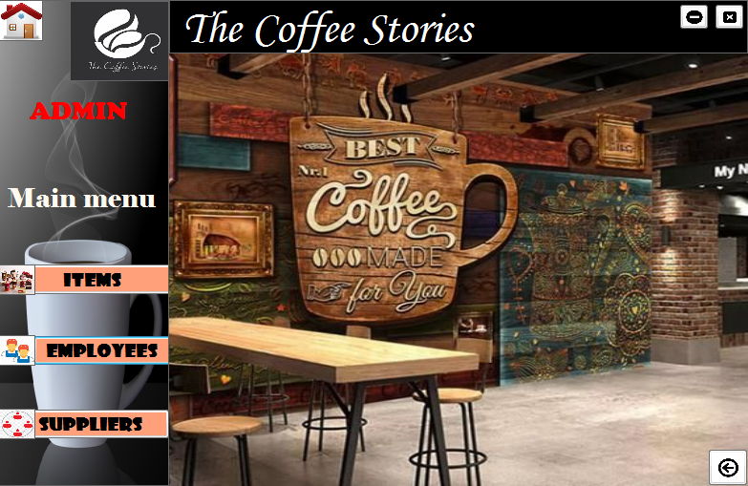

using System;

using System.Collections.Generic;

using System.ComponentModel;

using System.Data;

using System.Drawing;

using System.Linq;

using System.Text;

using System.Threading.Tasks;

using System.Windows.Forms;

namespace WindowsFormsApplication3

{

public partial class main_menu : Form

{

public main_menu()

{

InitializeComponent();

}

private void button1_Click(object sender, EventArgs e)

{

Items obj = new Items();

obj.Show();

this.Hide();

}

private void button2_Click(object sender, EventArgs e)

{

employee obj = new employee();

obj.Show();

this.Hide();

}

private void button3_Click(object sender, EventArgs e)

{

supplier obj = new supplier();

obj.Show();

this.Hide();

}

private void button5_Click(object sender, EventArgs e)

{

Application.Exit();

}

private void button4_Click(object sender, EventArgs e)

{

this.WindowState = FormWindowState.Minimized;

}

private void button6_Click(object sender, EventArgs e)

{

Login obj = new Login();

obj.Show();

this.Hide();

}

}

}

# Items

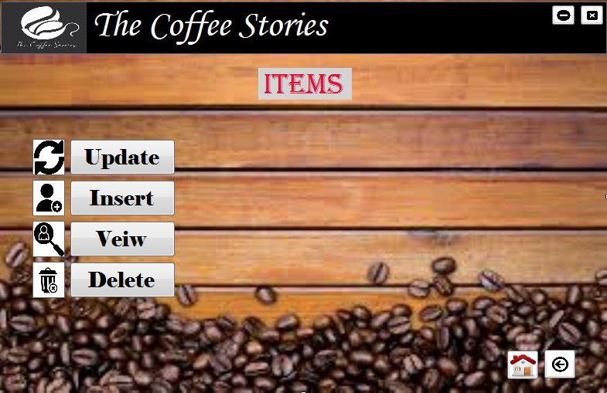

using System;

using System.Collections.Generic;

using System.ComponentModel;

using System.Data;

using System.Drawing;

using System.Linq;

using System.Text;

using System.Threading.Tasks;

using System.Windows.Forms;

using System.Data.SqlClient;

namespace WindowsFormsApplication3

{

public partial class Items : Form

{

public Items()

{

InitializeComponent();

}

private void button1_Click(object sender, EventArgs e)

{

Application.Exit();

}

private void updatebtn_Click(object sender, EventArgs e)

{

updateitem obj = new updateitem();

obj.Show();

this.Hide();

}

private void insertbtn_Click(object sender, EventArgs e)

{

additem obj = new additem();

obj.Show();

this.Hide();

}

private void Viewbtn_Click(object sender, EventArgs e)

{

viewitem obj = new viewitem();

obj.Show();

this.Hide();

}

private void Deletebtn_Click(object sender, EventArgs e)

{

deleteitem obj = new deleteitem();

obj.Show();

this.Hide();

}

private void button2_Click(object sender, EventArgs e)

{

this.WindowState = FormWindowState.Minimized;

}

private void button3_Click(object sender, EventArgs e)

{

main_menu obj = new main_menu();

obj.Show();

this.Hide();

}

private void button4_Click(object sender, EventArgs e)

{

main_menu obj = new main_menu();

obj.Show();

this.Hide();

}

}

}

# Employees

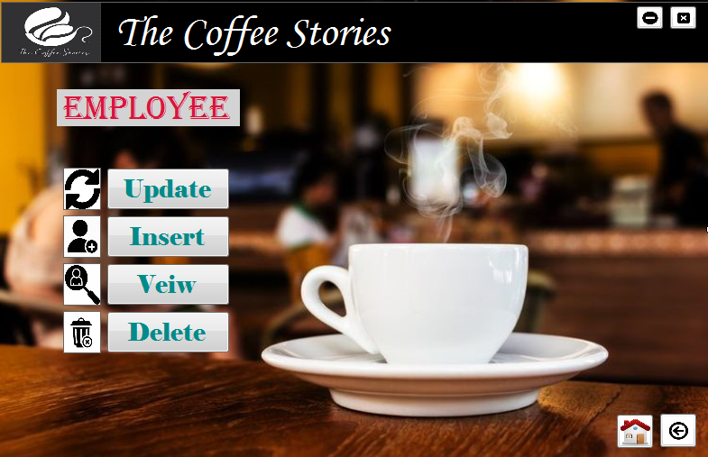

using System;

using System.Collections.Generic;

using System.ComponentModel;

using System.Data;

using System.Drawing;

using System.Linq;

using System.Text;

using System.Threading.Tasks;

using System.Windows.Forms;

namespace WindowsFormsApplication3

{

public partial class employee : Form

{

public employee()

{

InitializeComponent();

}

private void button1_Click(object sender, EventArgs e)

{

Application.Exit();

}

private void updatebtn_Click(object sender, EventArgs e)

{

UpdateEmployee obj = new UpdateEmployee();

obj.Show();

this.Hide();

}

private void insertbtn_Click(object sender, EventArgs e)

{

Addemployee obj = new Addemployee();

obj.Show();

this.Hide();

}

private void Viewbtn_Click(object sender, EventArgs e)

{

Veiwemployee obj = new Veiwemployee();

obj.Show();

this.Hide();

}

private void Deletebtn_Click(object sender, EventArgs e)

{

deleteemployee obj = new deleteemployee();

obj.Show();

this.Hide();

}

private void button2_Click(object sender, EventArgs e)

{

this.WindowState = FormWindowState.Minimized;

}

private void button3_Click(object sender, EventArgs e)

{

main_menu obj = new main_menu();

obj.Show();

this.Hide();

}

private void button4_Click(object sender, EventArgs e)

{

main_menu obj = new main_menu();

obj.Show();

this.Hide();

}

}

}

# Suppliers

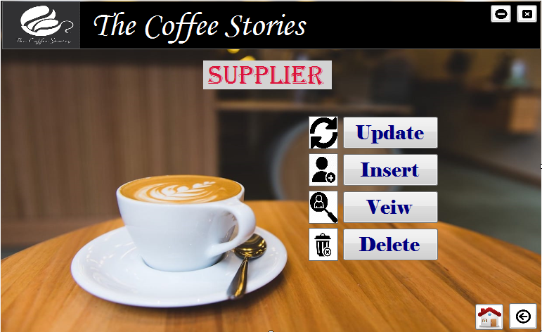

using System;

using System.Collections.Generic;

using System.ComponentModel;

using System.Data;

using System.Drawing;

using System.Linq;

using System.Text;

using System.Threading.Tasks;

using System.Windows.Forms;

namespace WindowsFormsApplication3

{

public partial class supplier : Form

{

public supplier()

{

InitializeComponent();

}

private void button1_Click(object sender, EventArgs e)

{

Application.Exit();

}

private void updatebtn_Click(object sender, EventArgs e)

{

UpdateSupplier obj = new UpdateSupplier();

obj.Show();

this.Hide();

}

private void insertbtn_Click(object sender, EventArgs e)

{

addsupplier obj = new addsupplier();

obj.Show();

this.Hide();

}

private void Viewbtn_Click(object sender, EventArgs e)

{

viewsupplier obj = new viewsupplier();

obj.Show();

this.Hide();

}

private void Deletebtn_Click(object sender, EventArgs e)

{

deletesupplier obj = new deletesupplier();

obj.Show();

this.Hide();

}

private void button2_Click(object sender, EventArgs e)

{

this.WindowState = FormWindowState.Minimized;

}

private void button3_Click(object sender, EventArgs e)

{

main_menu obj = new main_menu();

obj.Show();

this.Hide();

}

private void button4_Click(object sender, EventArgs e)

{

main_menu obj = new main_menu();

obj.Show();

this.Hide();

}

}

}

# Update Item

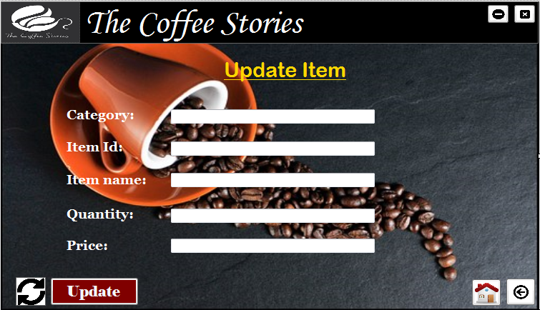

using System;

using System.Collections.Generic;

using System.ComponentModel;

using System.Data;

using System.Drawing;

using System.Linq;

using System.Text;

using System.Threading.Tasks;

using System.Windows.Forms;

using System.Data.SqlClient;

namespace WindowsFormsApplication3

{

public partial class updateitem : Form

{

public updateitem()

{

InitializeComponent();

}

SqlConnection con = new SqlConnection(@"Data Source=NIPUNI-PC;Initial Catalog=Coffees;Integrated Security=True");

private void button1_Click(object sender, EventArgs e)

{

Application.Exit();

}

private void button2_Click(object sender, EventArgs e)

{

this.WindowState = FormWindowState.Minimized;

}

private void button4_Click(object sender, EventArgs e)

{

Items obj = new Items();

obj.Show();

this.Hide();

}

private void button3_Click(object sender, EventArgs e)

{

main_menu obj = new main_menu();

obj.Show();

this.Hide();

}

private void Updatebtn_Click(object sender, EventArgs e)

{

try

{

//taking interface frm GUI

string Category = textBox1.Text;

string Item_ID = textBox2.Text;

string Item_name = textBox3.Text;

string Quantity = textBox4.Text;

string Price = textBox5.Text;

//sql query

string update_query = "UPDATE Item SET Category='" + textBox1.Text + "', Item_ID= '" + textBox2.Text + "', Item_name='" + textBox3.Text + "', Quantity='" + textBox4.Text + "', Price='" + textBox5.Text + "' WHERE Item_ID = '" + textBox2.Text + "'";

//SQL comman

SqlCommand cmnd = new SqlCommand(update_query, con);

con.Open();

//Execution of the command

cmnd.ExecuteNonQuery();

// Successful message after the execution

MessageBox.Show("Updated Sucessfully!");

}

catch (Exception ex)

{

MessageBox.Show("Error While Updating!" + ex);

}

finally

{

//closing the connection

con.Close();

}

}

}

}

# Add Item

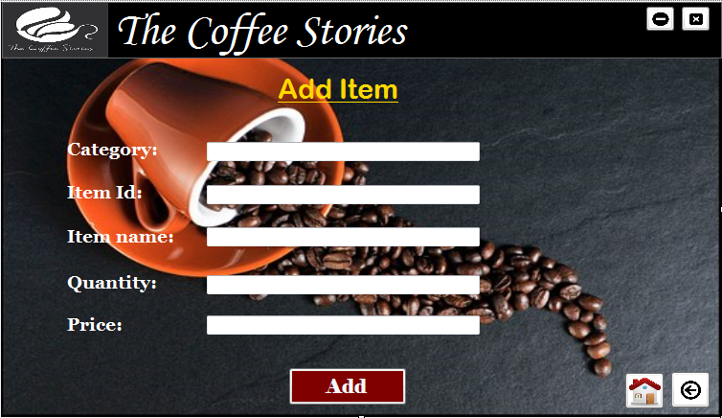

using System;

using System.Collections.Generic;

using System.ComponentModel;

using System.Data;

using System.Drawing;

using System.Linq;

using System.Text;

using System.Threading.Tasks;

using System.Windows.Forms;

using System.Data.SqlClient;

namespace WindowsFormsApplication3

{

public partial class additem : Form

{

public additem()

{

InitializeComponent();

}

SqlConnection con = new SqlConnection(@"Data Source=NIPUNI-PC;Initial Catalog=Coffees;Integrated Security=True");

private void button3_Click(object sender, EventArgs e)

{

Application.Exit();

}

private void button2_Click(object sender, EventArgs e)

{

this.WindowState = FormWindowState.Minimized;

}

private void button4_Click(object sender, EventArgs e)

{

Items obj = new Items();

obj.Show();

this.Hide();

}

private void button5_Click(object sender, EventArgs e)

{

main_menu obj = new main_menu();

obj.Show();

this.Hide();

}

private void button1_Click(object sender, EventArgs e)

{

try

{

//taking interface frm GUI

string Category = textBox1.Text;

string Item_ID = textBox2.Text;

string Item_name = textBox3.Text;

string Quantity = textBox4.Text;

string Price = textBox5.Text;

//sql query

string query_insert = "INSERT INTO Item (Category, Item_ID, Item_name, Quantity, Price ) VALUES ('" + Category + "','" + Item_ID + "','" + Item_name + "', '" + Quantity + "','" + Price + "')";

//SQL command

SqlCommand cmnd = new SqlCommand(query_insert, con);

con.Open();

//Execution of the command

cmnd.ExecuteNonQuery();

// Successful message after the execution

MessageBox.Show("Added Sucessfully!");

}

catch (Exception ex)

{

MessageBox.Show("Error While Adding" + ex);

}

finally

{

//closing the connection

con.Close();

}

}

}

# View Item

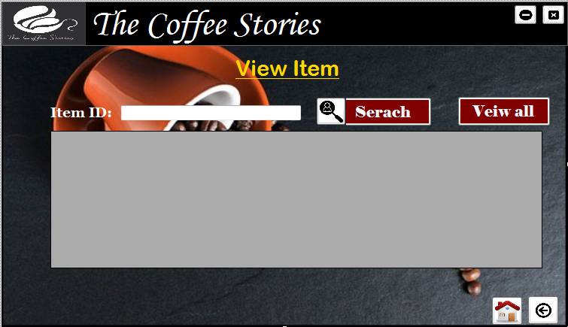

using System;

using System.Collections.Generic;

using System.ComponentModel;

using System.Data;

using System.Drawing;

using System.Linq;

using System.Text;

using System.Threading.Tasks;

using System.Windows.Forms;

using System.Data.SqlClient;

namespace WindowsFormsApplication3

{

public partial class viewitem : Form

{

public viewitem()

{

InitializeComponent();

}

SqlConnection con = new SqlConnection(@"Data Source=NIPUNI-PC;Initial Catalog=Coffees;Integrated Security=True");

private void button1_Click(object sender, EventArgs e)

{

Application.Exit();

}

private void button2_Click(object sender, EventArgs e)

{

this.WindowState = FormWindowState.Minimized;

}

private void button4_Click(object sender, EventArgs e)

{

Items obj = new Items();

obj.Show();

this.Hide();

}

private void button3_Click(object sender, EventArgs e)

{

main_menu obj = new main_menu();

obj.Show();

this.Hide();

}

private void searchbtn_Click(object sender, EventArgs e)

{

try

{

con.Open();

string serach_query = "SELECT * FROM Item WHERE Item_ID = " + int.Parse(textBoxID.Text);

SqlDataAdapter SDA = new SqlDataAdapter(serach_query, con);

DataTable dt = new DataTable();

SDA.Fill(dt);

dataGridViewItems.DataSource = dt;

}

catch (Exception ex)

{

MessageBox.Show("Error while searching!"+ ex);

}

finally

{

con.Close();

}

}

private void Viewbtn_Click(object sender, EventArgs e)

{

try

{

con.Open();

string serach_query = "SELECT * FROM Item ";

SqlDataAdapter SDA = new SqlDataAdapter(serach_query, con);

DataTable dt = new DataTable();

SDA.Fill(dt);

dataGridViewItems.DataSource = dt;

}

catch (Exception ex)

{

MessageBox.Show("Error while searching!" + ex);

}

finally

{

con.Close();

}

}

}

}

# Delete Item

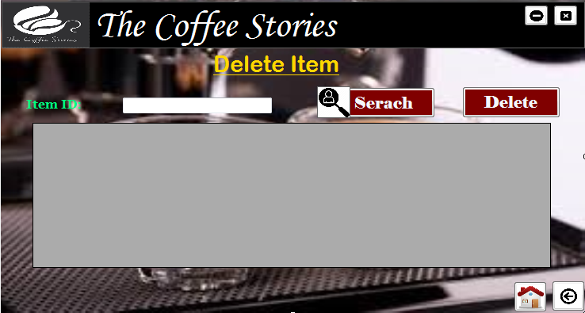

using System;

using System.Collections.Generic;

using System.ComponentModel;

using System.Data;

using System.Drawing;

using System.Linq;

using System.Text;

using System.Threading.Tasks;

using System.Windows.Forms;

namespace WindowsFormsApplication3

{

public partial class deleteitem : Form

{

public deleteitem()

{

InitializeComponent();

}

private void button3_Click(object sender, EventArgs e)

{

Application.Exit();

}

private void button2_Click(object sender, EventArgs e)

{

this.WindowState = FormWindowState.Minimized;

}

private void button4_Click(object sender, EventArgs e)

{

Items obj = new Items();

obj.Show();

this.Hide();

}

private void button5_Click(object sender, EventArgs e)

{

main_menu obj = new main_menu();

obj.Show();

this.Hide();

}

}

}

# Update Employee

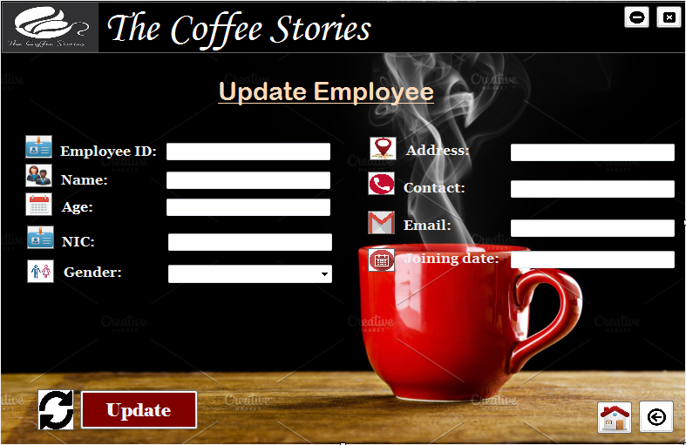

using System;

using System.Collections.Generic;

using System.ComponentModel;

using System.Data;

using System.Drawing;

using System.Linq;

using System.Text;

using System.Threading.Tasks;

using System.Windows.Forms;

using System.Data.SqlClient;

namespace WindowsFormsApplication3

{

public partial class UpdateEmployee : Form

{

public UpdateEmployee()

{

InitializeComponent();

}

SqlConnection con = new SqlConnection(@"Data Source=NIPUNI-PC;Initial Catalog=Coffees;Integrated Security=True");

private void button3_Click(object sender, EventArgs e)

{

Application.Exit();

}

private void button2_Click(object sender, EventArgs e)

{

this.WindowState = FormWindowState.Minimized;

}

private void backbtn_Click(object sender, EventArgs e)

{

employee obj = new employee();

obj.Show();

this.Hide();

}

private void Homebtn_Click(object sender, EventArgs e)

{

main_menu obj = new main_menu();

obj.Show();

this.Hide();

}

private void updatebtn_Click(object sender, EventArgs e)

{

try

{

//taking interface from GUI

string Employee_ID = textBoxEID.Text;

string Name = textBox8.Text;

int Age = int.Parse(textBoxEAge.Text);

string NIC = textBoxNIC.Text;

string Gender = comboBox1.Text;

string Address = textBoxEAddress.Text;

int Contact = int.Parse(textBoxEcontact.Text);

string Email = textBoxEmail.Text;

string Joining_date = textBoxJoin.Text;

//sql query

string update_query = "UPDATE Employee1 SET Employee_ID='" + textBoxEID.Text + "', Name= '" + textBox8.Text + "', Age='" + textBoxEAge.Text + "', NIC='"+textBoxNIC.Text+"',Gender='" + comboBox1 + "', Address='" + textBoxEAddress.Text + "', Contact='" + textBoxEcontact.Text + "', Email= '" + textBoxEmail.Text + "',Joining_date='" + textBoxJoin.Text + "' WHERE Employee_ID = '" + textBoxEID.Text + "'";

//SQL comman

SqlCommand cmnd = new SqlCommand(update_query, con);

con.Open();

//Execution of the command

cmnd.ExecuteNonQuery();

// Successful message after the execution

MessageBox.Show("Updated Sucessfully!");

}

catch (Exception ex)

{

MessageBox.Show("Error While Updating!" + ex);

}

finally

{

//closing the connection

con.Close();

}

}

private void UpdateEmployee_Load(object sender, EventArgs e)

{

}

}

}

# Add Employee

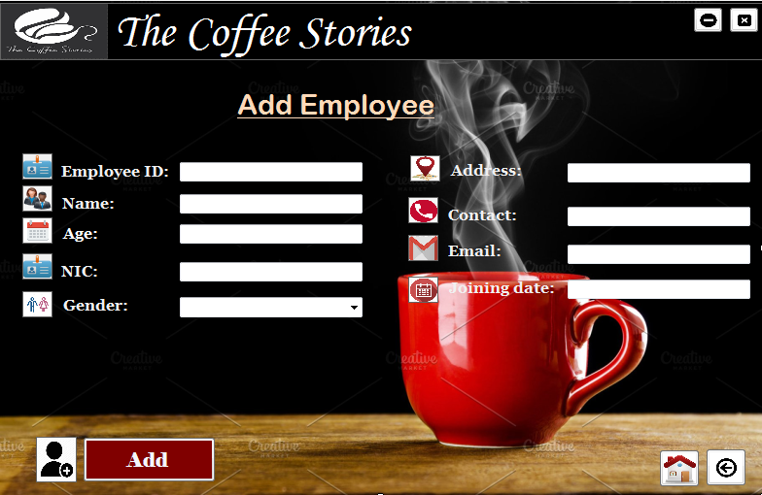

using System;

using System.Collections.Generic;

using System.ComponentModel;

using System.Data;

using System.Drawing;

using System.Linq;

using System.Text;

using System.Threading.Tasks;

using System.Windows.Forms;

using System.Data.SqlClient;

namespace WindowsFormsApplication3

{

public partial class Addemployee : Form

{

public Addemployee()

{

InitializeComponent();

}

SqlConnection con = new SqlConnection(@"Data Source=NIPUNI-PC;Initial Catalog=Coffees;Integrated Security=True");

private void button3_Click(object sender, EventArgs e)

{

Application.Exit();

}

private void button2_Click(object sender, EventArgs e)

{

this.WindowState = FormWindowState.Minimized;

}

private void backbtn_Click(object sender, EventArgs e)

{

employee obj = new employee();

obj.Show();

this.Hide();

}

private void Homebtn_Click(object sender, EventArgs e)

{

main_menu obj = new main_menu();

obj.Show();

this.Hide();

}

private void updatebtn_Click(object sender, EventArgs e)

{

try

{

//taking interface frm GUI

string Employee_ID = textBoxEID.Text;

string Name = textBox8.Text;

int Age = int.Parse(textBoxEAge.Text);

string NIC = textBoxNIC.Text;

string Gender= comboBox1.Text;

string Address = textBoxEAddress.Text;

int Contact = int.Parse(textBoxEcontact.Text);

string Email = textBoxEmail.Text;

string Joining_date = textBoxJoin.Text;

//sql query

string query_insert = "INSERT INTO Employee1 VALUES ('" + Employee_ID + "','" + Name + "','" + Age + "', '"+NIC+"', '" + Gender + "','" + Address + "','" + Contact + "','" + Email + "','" + Joining_date + "')";

//SQL command

SqlCommand cmnd = new SqlCommand(query_insert, con);

con.Open();

//Execution of the command

cmnd.ExecuteNonQuery();

// Successful message after the execution

MessageBox.Show("Added Sucessfully!");

}

catch(Exception ex)

{

MessageBox.Show("Error While Adding" + ex);

}

finally

{

//closing the connection

con.Close();

}

}

}

}

# View Employee

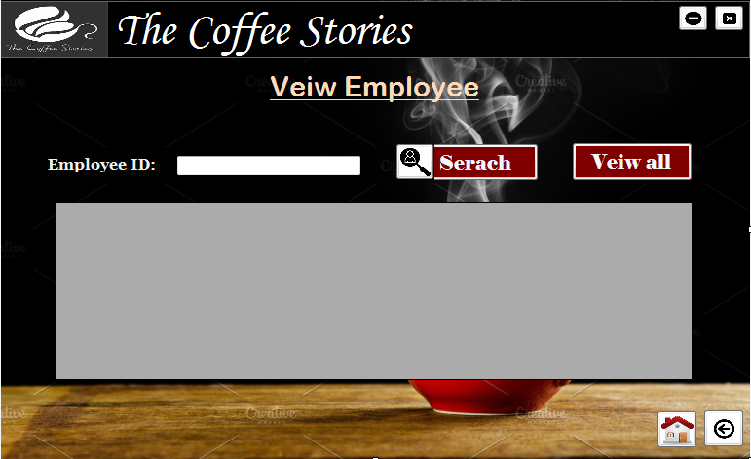

using System;

using System.Collections.Generic;

using System.ComponentModel;

using System.Data;

using System.Drawing;

using System.Linq;

using System.Text;

using System.Threading.Tasks;

using System.Windows.Forms;

using System.Data.SqlClient;

namespace WindowsFormsApplication3

{

public partial class Veiwemployee : Form

{

public Veiwemployee()

{

InitializeComponent();

}

SqlConnection con = new SqlConnection(@"Data Source=NIPUNI-PC;Initial Catalog=Coffees;Integrated Security=True");

private void button1_Click(object sender, EventArgs e)

{

Application.Exit();

}

private void button2_Click(object sender, EventArgs e)

{

this.WindowState = FormWindowState.Minimized;

}

private void button4_Click(object sender, EventArgs e)

{

employee obj = new employee();

obj.Show();

this.Hide();

}

private void button3_Click(object sender, EventArgs e)

{

main_menu obj = new main_menu();

obj.Show();

this.Hide();

}

private void Searchbtn_Click(object sender, EventArgs e)

{

try

{

con.Open();

string serach_query = "SELECT * FROM Employee1 WHERE Employee_ID = " + int.Parse(textBoxEID.Text);

SqlDataAdapter SDA = new SqlDataAdapter(serach_query, con);

DataTable dt = new DataTable();

SDA.Fill(dt);

dataGridViewEmployee.DataSource = dt;

}

catch (Exception ex)

{

MessageBox.Show("Error while searching!" + ex);

}

finally

{

con.Close();

}

}

private void Viewallbtn_Click(object sender, EventArgs e)

{

try

{

con.Open();

string serach_query = "SELECT * FROM Employee1 ";

SqlDataAdapter SDA = new SqlDataAdapter(serach_query, con);

DataTable dt = new DataTable();

SDA.Fill(dt);

dataGridViewEmployee.DataSource = dt;

}

catch (Exception ex)

{

MessageBox.Show("Error while searching!" + ex);

}

finally

{

con.Close();

}

}

}

}

# Delete Employee

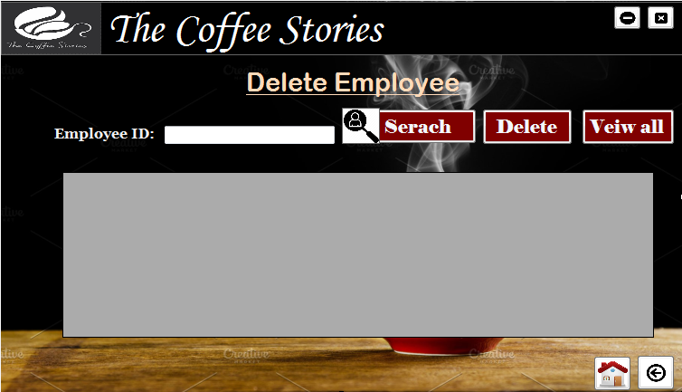

using System;

using System.Collections.Generic;

using System.ComponentModel;

using System.Data;

using System.Drawing;

using System.Linq;

using System.Text;

using System.Threading.Tasks;

using System.Windows.Forms;

using System.Data.SqlClient;

namespace WindowsFormsApplication3

{

public partial class deleteemployee : Form

{

public deleteemployee()

{

InitializeComponent();

}

SqlConnection con = new SqlConnection(@"Data Source=NIPUNI-PC;Initial Catalog=Coffees;Integrated Security=True");

private void button3_Click(object sender, EventArgs e)

{

Application.Exit();

}

private void button2_Click(object sender, EventArgs e)

{

this.WindowState = FormWindowState.Minimized;

}

private void button4_Click(object sender, EventArgs e)

{

employee obj = new employee();

obj.Show();

this.Hide();

}

private void button5_Click(object sender, EventArgs e)

{

main_menu obj = new main_menu();

obj.Show();

this.Hide();

}

private void searchbtn_Click(object sender, EventArgs e)

{

try

{

con.Open();

string serach_query = "SELECT * FROM Employee WHERE Employee_ID = " + int.Parse(textBoxEID.Text);

SqlDataAdapter SDA = new SqlDataAdapter(serach_query, con);

DataTable dt = new DataTable();

SDA.Fill(dt);

dataGridViewEmployee.DataSource = dt;

}

catch (Exception ex)

{

MessageBox.Show("Error while searching!" + ex);

}

finally

{

con.Close();

}

}

private void deletebtn_Click(object sender, EventArgs e)

{

try

{

con.Open();

string delete_query = "DELETE FROM Employee1 WHERE Employee_ID=" + int.Parse(textBoxEID.Text);

SqlDataAdapter SDA = new SqlDataAdapter(delete_query, con);

DataTable dt = new DataTable();

SDA.Fill(dt);

MessageBox.Show("Deleted Successfully!" );

}

catch(Exception ex)

{

MessageBox.Show("Error while Deleting!" + ex);

}

finally

{

con.Close();

}

}

private void Viewallbtn_Click(object sender, EventArgs e)

{

try

{

con.Open();

string serach_query = "SELECT * FROM Employee1 ";

SqlDataAdapter SDA = new SqlDataAdapter(serach_query, con);

DataTable dt = new DataTable();

SDA.Fill(dt);

dataGridViewEmployee.DataSource = dt;

}

catch (Exception ex)

{

MessageBox.Show("Error while searching!" + ex);

}

finally

{

con.Close();

}

}

}

}

# Update Supplier

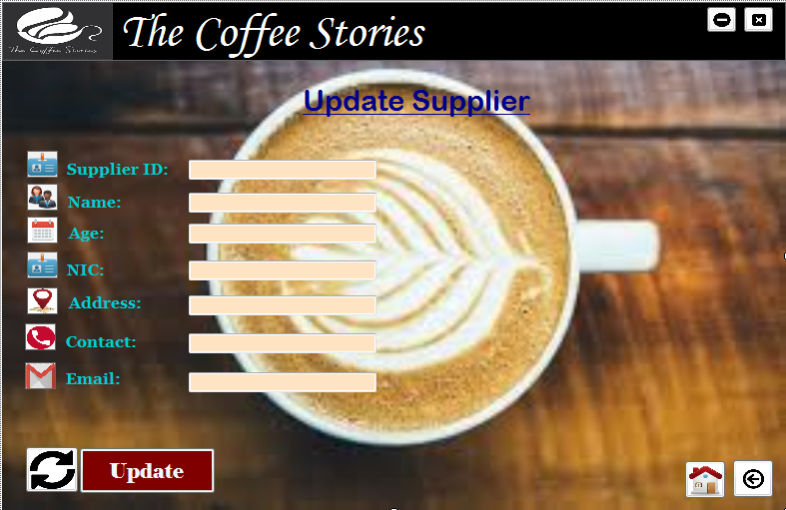

using System;

using System.Windows.Forms;

using System.Data.SqlClient;

namespace WindowsFormsApplication3

{

public partial class UpdateSupplier : Form

{

public UpdateSupplier()

{

InitializeComponent();

}

SqlConnection con = new SqlConnection(@"Data Source=NIPUNI-PC;Initial Catalog=Coffees;Integrated Security=True");

private void button1_Click(object sender, EventArgs e)

{

Application.Exit();

}

private void button2_Click(object sender, EventArgs e)

{

this.WindowState = FormWindowState.Minimized;

}

private void buttonBack_Click(object sender, EventArgs e)

{

supplier obj = new supplier();

obj.Show();

this.Hide();

}

private void buttonHome_Click(object sender, EventArgs e)

{

main_menu obj = new main_menu();

obj.Show();

this.Hide();

}

private void Addbtn_Click(object sender, EventArgs e)

{

try

{

//taking interface frm GUI

string Supplier_ID = textBoxSupID.Text;

string Name = textBoxSName.Text;

int Age = int.Parse(textBoxSAge.Text);

string NIC = textBoxNIC.Text;

string Address = textBoxSAddress.Text;

int Contact = int.Parse(textBoxSContact.Text);

string Email = textBoxSEmail.Text;

//sql query

string update_query = "UPDATE Supplier SET Supplier_ID='" + textBoxSupID.Text + "', Name= '" + textBoxSName.Text + "', Age='" + textBoxSAge.Text + "', Address='" + textBoxSAddress.Text + "', Contact='" + textBoxSContact.Text + "', Email= '" + textBoxSEmail.Text + "' WHERE Supplier_ID = '" + textBoxSupID.Text + "'";

//SQL comman

SqlCommand cmnd = new SqlCommand(update_query, con);

con.Open();

//Execution of the command

cmnd.ExecuteNonQuery();

// Successful message after the execution

MessageBox.Show("Updated Sucessfully!");

}

catch (Exception ex)

{

MessageBox.Show("Error While Updating!" + ex);

}

finally

{

//closing the connection

con.Close();

}

}

}

}

# Insert Supplier

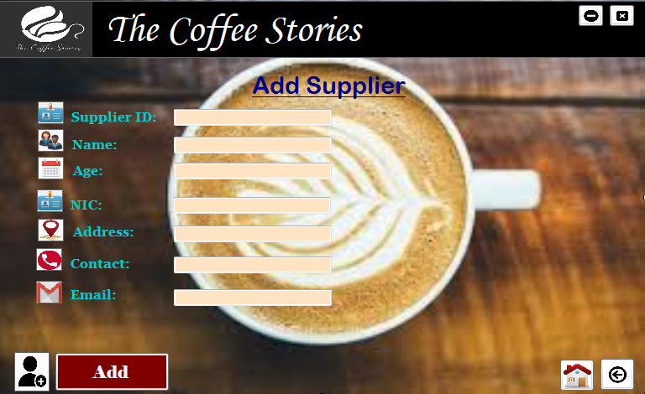

using System;

using System.Collections.Generic;

using System.ComponentModel;

using System.Data;

using System.Drawing;

using System.Linq;

using System.Text;

using System.Threading.Tasks;

using System.Windows.Forms;

using System.Data.SqlClient;

namespace WindowsFormsApplication3

{

public partial class addsupplier : Form

{

public addsupplier()

{

InitializeComponent();

}

SqlConnection con = new SqlConnection(@"Data Source=NIPUNI-PC;Initial Catalog=Coffees;Integrated Security=True");

private void button1_Click(object sender, EventArgs e)

{

Application.Exit();

}

private void button2_Click(object sender, EventArgs e)

{

this.WindowState = FormWindowState.Minimized;

}

private void button4_Click(object sender, EventArgs e)

{

supplier obj = new supplier();

obj.Show();

this.Hide();

}

private void button3_Click(object sender, EventArgs e)

{

main_menu obj = new main_menu();

obj.Show();

this.Hide();

}

private void Addbtn_Click(object sender, EventArgs e)

{

try

{

//taking interface frm GUI

string Supplier_ID = textBoxSupId.Text;

string Name = textBoxSupName.Text;

int Age = int.Parse(textBoxSupAge.Text);

string NIC = textBoxNIC.Text;

string Address = textBoxSAddress.Text;

int Contact = int.Parse(textBoxSContact.Text);

string Email = textBoxSupEmail.Text;

//sql query

string query_insert = "INSERT INTO Supplier (Supplier_ID, Name, Age, NIC, Address, Contact, Email ) VALUES ('" + Supplier_ID + "','" + Name + "','" + Age + "','"+ NIC +"', '" + Address + "','" + Contact + "','" + Email + "')";

//SQL command

SqlCommand cmnd = new SqlCommand(query_insert, con);

con.Open();

//Execution of the command

cmnd.ExecuteNonQuery();

// Successful message after the execution

MessageBox.Show("Added Sucessfully!");

}

catch (Exception ex)

{

MessageBox.Show("Error While Adding" + ex);

}

finally

{

//closing the connection

con.Close();

}

}

}

}

# View Supplier

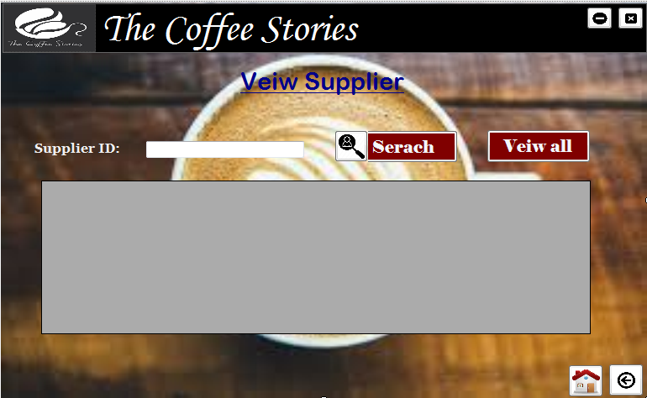

using System;

using System.Collections.Generic;

using System.ComponentModel;

using System.Data;

using System.Drawing;

using System.Linq;

using System.Text;

using System.Threading.Tasks;

using System.Windows.Forms;

using System.Data.SqlClient;

namespace WindowsFormsApplication3

{

public partial class viewsupplier : Form

{

public viewsupplier()

{

InitializeComponent();

}

SqlConnection con = new SqlConnection(@"Data Source=NIPUNI-PC;Initial Catalog=Coffees;Integrated Security=True");

private void button1_Click(object sender, EventArgs e)

{

Application.Exit();

}

private void button2_Click(object sender, EventArgs e)

{

this.WindowState = FormWindowState.Minimized;

}

private void button4_Click(object sender, EventArgs e)

{

supplier obj = new supplier();

obj.Show();

this.Hide();

}

private void button3_Click(object sender, EventArgs e)

{

main_menu obj = new main_menu();

obj.Show();

this.Hide();

}

private void Searchbtn_Click(object sender, EventArgs e)

{

try

{

con.Open();

string serach_query = "SELECT * FROM Supplier WHERE Supplier_ID = " + int.Parse(textBoxSID.Text) ;

SqlDataAdapter SDA = new SqlDataAdapter(serach_query, con);

DataTable dt = new DataTable();

SDA.Fill(dt);

dataGridViewSupplier.DataSource = dt;

}

catch (Exception ex)

{

MessageBox.Show("Error while searching!" + ex);

}

finally

{

con.Close();

}

}

private void Viewallbtn_Click(object sender, EventArgs e)

{

try

{

con.Open();

string serach_query = "SELECT * FROM Supplier ";

SqlDataAdapter SDA = new SqlDataAdapter(serach_query, con);

DataTable dt = new DataTable();

SDA.Fill(dt);

dataGridViewSupplier.DataSource = dt;

}

catch (Exception ex)

{

MessageBox.Show("Error while searching!" + ex);

}

finally

{

con.Close();

}

}

}

}

# Delete Supplier

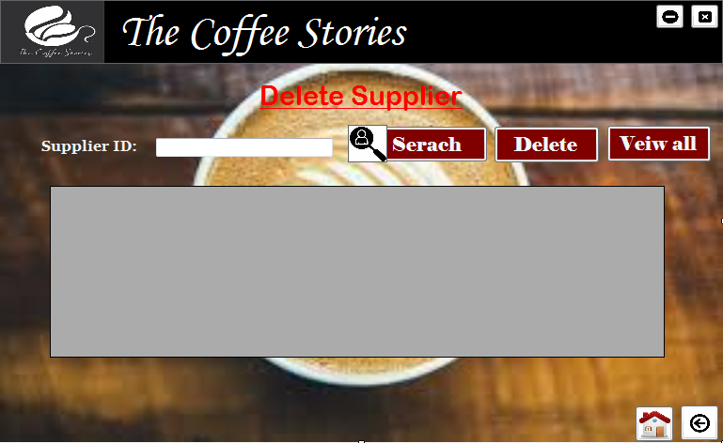

using System;

using System.Collections.Generic;

using System.ComponentModel;

using System.Data;

using System.Drawing;

using System.Linq;

using System.Text;

using System.Threading.Tasks;

using System.Windows.Forms;

using System.Data.SqlClient;

namespace WindowsFormsApplication3

{

public partial class deletesupplier : Form

{

public deletesupplier()

{

InitializeComponent();

}

SqlConnection con = new SqlConnection(@"Data Source=NIPUNI-PC;Initial Catalog=Coffees;Integrated Security=True");

private void button3_Click(object sender, EventArgs e)

{

Application.Exit();

}

private void button2_Click(object sender, EventArgs e)

{

this.WindowState = FormWindowState.Minimized;

}

private void button4_Click(object sender, EventArgs e)

{

supplier obj = new supplier();

obj.Show();

this.Hide();

}

private void button5_Click(object sender, EventArgs e)

{

main_menu obj = new main_menu();

obj.Show();

this.Hide();

}

private void searchbtn_Click(object sender, EventArgs e)

{

try

{

con.Open();

string serach_query = "SELECT * FROM Supplier WHERE Supplier_ID = " + int.Parse(textBoxSID.Text);

SqlDataAdapter SDA = new SqlDataAdapter(serach_query, con);

DataTable dt = new DataTable();

SDA.Fill(dt);

dataGridViewSupplier.DataSource = dt;

}

catch (Exception ex)

{

MessageBox.Show("Error while searching!" + ex);

}

finally

{

con.Close();

}

}

private void deletebtn_Click(object sender, EventArgs e)

{

try

{

con.Open();

string delete_query = "DELETE FROM Supplier WHERE Supplier_ID=" + int.Parse(textBoxSID.Text);

SqlDataAdapter SDA = new SqlDataAdapter(delete_query, con);

DataTable dt = new DataTable();

SDA.Fill(dt);

MessageBox.Show("Deleted Successfully!");

}

catch (Exception ex)

{

MessageBox.Show("Error while Deleting!" + ex);

}

finally

{

con.Close();

}

}

private void Viewallbtn_Click(object sender, EventArgs e)

{

try

{

con.Open();

string serach_query = "SELECT * FROM Supplier ";

SqlDataAdapter SDA = new SqlDataAdapter(serach_query, con);

DataTable dt = new DataTable();

SDA.Fill(dt);

dataGridViewSupplier.DataSource = dt;

}

catch (Exception ex)

{

MessageBox.Show("Error while searching!" + ex);

}

finally

{

con.Close();

}

}

}

}

# Customer Page

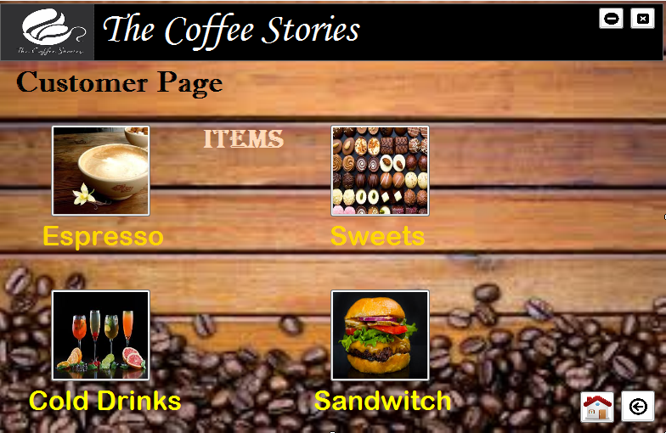

using System;

using System.Collections.Generic;

using System.ComponentModel;

using System.Data;

using System.Drawing;

using System.Linq;

using System.Text;

using System.Threading.Tasks;

using System.Windows.Forms;

namespace WindowsFormsApplication3

{

public partial class ItemsCustomer : Form

{

public ItemsCustomer()

{

InitializeComponent();

}

private void button1_Click(object sender, EventArgs e)

{

Application.Exit();

}

private void button5_Click(object sender, EventArgs e)

{

Espresso obj = new Espresso();

obj.Show();

this.Hide();

}

private void buttonSweets_Click(object sender, EventArgs e)

{

sweets obj = new sweets();

obj.Show();

this.Hide();

}

private void buttonCold_Click(object sender, EventArgs e)

{

Cold_drinks obj = new Cold_drinks();

obj.Show();

this.Hide();

}

private void buttonSandwitch_Click(object sender, EventArgs e)

{

Sandwitches obj = new Sandwitches();

obj.Show();

this.Hide();

}

private void button2_Click(object sender, EventArgs e)

{

this.WindowState = FormWindowState.Minimized;

}

private void button4_Click(object sender, EventArgs e)

{

Login obj = new Login();

obj.Show();

this.Hide();

}

private void button3_Click(object sender, EventArgs e)

{

main_menu obj = new main_menu();

obj.Show();

this.Hide();

}

}

}

# Espresso

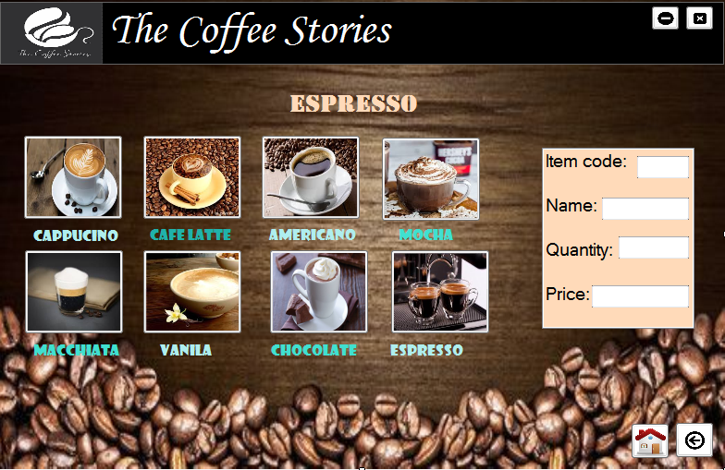

using System;

using System.Collections.Generic;

using System.ComponentModel;

using System.Data;

using System.Drawing;

using System.Linq;

using System.Text;

using System.Threading.Tasks;

using System.Windows.Forms;

namespace WindowsFormsApplication3

{

public partial class Espresso : Form

{

public Espresso()

{

InitializeComponent();

}

private void button1_Click(object sender, EventArgs e)

{

Application.Exit();

}

private void button2_Click(object sender, EventArgs e)

{

this.WindowState = FormWindowState.Minimized;

}

private void button3_Click(object sender, EventArgs e)

{

main_menu obj = new main_menu();

obj.Show();

this.Hide();

}

private void button4_Click(object sender, EventArgs e)

{

ItemsCustomer obj = new ItemsCustomer();

obj.Show();

this.Hide();

}

}

}

# Beverages

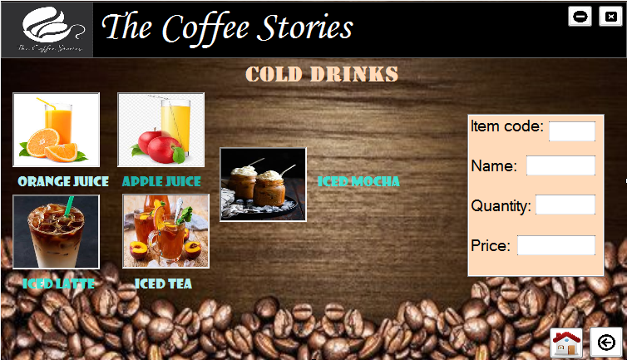

using System;

using System.Collections.Generic;

using System.ComponentModel;

using System.Data;

using System.Drawing;

using System.Linq;

using System.Text;

using System.Threading.Tasks;

using System.Windows.Forms;

namespace WindowsFormsApplication3

{

public partial class Cold_drinks : Form

{

public Cold_drinks()

{

InitializeComponent();

}

private void button1_Click(object sender, EventArgs e)

{

Application.Exit();

}

private void button2_Click(object sender, EventArgs e)

{

this.WindowState = FormWindowState.Minimized;

}

private void button3_Click(object sender, EventArgs e)

{

main_menu obj = new main_menu();

obj.Show();

this.Hide();

}

private void button4_Click(object sender, EventArgs e)

{

ItemsCustomer obj = new ItemsCustomer();

obj.Show();

this.Hide();

}

}

}

# Sandwiches

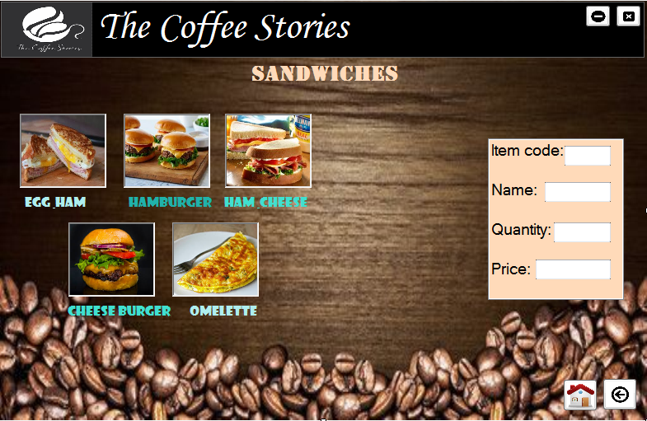

using System;

using System.Collections.Generic;

using System.ComponentModel;

using System.Data;

using System.Drawing;

using System.Linq;

using System.Text;

using System.Threading.Tasks;

using System.Windows.Forms;

namespace WindowsFormsApplication3

{

public partial class Sandwitches : Form

{

public Sandwitches()

{

InitializeComponent();

}

private void button1_Click(object sender, EventArgs e)

{

Application.Exit();

}

private void button2_Click(object sender, EventArgs e)

{

this.WindowState = FormWindowState.Minimized;

}

private void button3_Click(object sender, EventArgs e)

{

main_menu obj = new main_menu();

obj.Show();

this.Hide();

}

private void button4_Click(object sender, EventArgs e)

{

ItemsCustomer obj = new ItemsCustomer();

obj.Show();

this.Hide();

}

}

}

# Sweets

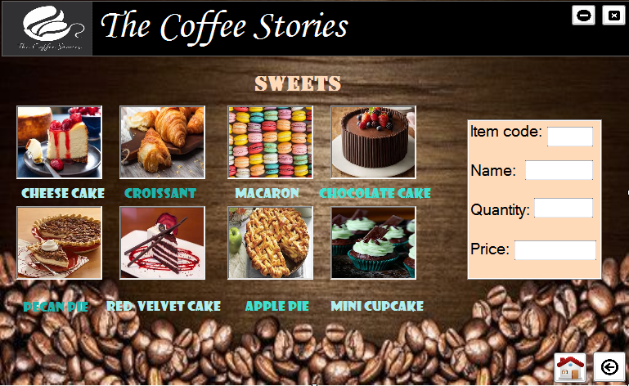

using System;

using System.Collections.Generic;

using System.ComponentModel;

using System.Data;

using System.Drawing;

using System.Linq;

using System.Text;

using System.Threading.Tasks;

using System.Windows.Forms;

namespace WindowsFormsApplication3

{

public partial class sweets : Form

{

public sweets()

{

InitializeComponent();

}

private void button1_Click(object sender, EventArgs e)

{

Application.Exit();

}

private void button2_Click(object sender, EventArgs e)

{

this.WindowState = FormWindowState.Minimized;

}

private void button3_Click(object sender, EventArgs e)

{

main_menu obj = new main_menu();

obj.Show();

this.Hide();

}

private void button4_Click(object sender, EventArgs e)

{

ItemsCustomer obj = new ItemsCustomer();

obj.Show();

this.Hide();

}

}

}

}

# Test Plan

|  |  |  |
| --- | --- | --- |
| Input | Expected Output | Actual Output |
| Login with correct username and password | “*Successfully login to the System*” |  |
| Login with incorrect username and password | “*Invalid login to the System*” |  |
| Add Items/ Suppliers/ Employees | “*Added successfully*” |  |
| Update Items/ Suppliers/ Employees | “*Updated successfully*” |  |
| Delete Items/ Suppliers/ Employees | “*Deleted successfully*” |  |

# Future Scope

In the future we wish to make different changes to this Coffee shop Management System so that it performs the following operations.

* Automatic Stock Control.
* Data validation in bill payments.
* To provide delivery system.
* To provide online payments using visa card or PayPal.
* Add more security mechanism.
* To become more user friendly system.

# Conclusion

At the end the system was build up in order to insert update delete and view in items, supplier and Employees. And also Customer page was created to view the food items in the shop.

# References

* (87) Developing Step By Step Point of Sale and Inventory System In C#.Net and SQL Server Full Tutorial - YouTube
* (128) How to create a Coffee Shop Management System Project In C# - YouTube
* (128) Source Code for Splash Form| Coffee Shop Management System Project| IT Project – YouTube
* https://www.kashipara.com/project/c-net/2798/coffee-shop-management-system
* https://code-projects.org/simple-coffee-shop-system-in-c-with-source-code
* https://www.techprofree.com/coffee-shop-management-system-project-with-source-code
* http://www.projectjugad.com/coffee-shop-management-system/
* https://www.jobz99.com/2019/02/coffee-shop-system-in-c-with-source.html